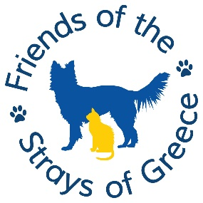
VALENTINES THEMED QUIZ NIGHT 2026

SINCERE APOLOGIES FOR THE SHORT NOTICE.
Please support us by entering a team of between 2 and 6 people – if you want to be in a bigger team but cannot find extra members, please let me know and we will arrange seating so other teams of 2 can be paired up.
It’s Good to talk! (But not during the questions obviously! 😊)

- Date: Sunday 8 February 2026
- Time: Doors open 5pm- Quiz starts at 6pm
- Venue: Wimborne Town Football Club, 16 Ainsley Rd, Wimborne Minster BH21 2FU
- Price: £14.00 per person to include food as detailed below
- Tombola
- Please bring a £1 coin to play ‘heads and tails’
- Please advise by end of January, of food choice, team name and number of members

Team Name ………………… Contact Name …………..…………

Tel: …………………………. Email ………………………………

Chedder Ploughman Qty: …….
Ham Ploughman Qty: …….

Please advise any dietary requirements and make a note of your order
……………………………………………………………………………………

Payment Options:

By bank transfer to Lloyds Bank, sort code 30-93-25,
Account No 01513726 and name: Friends of the Strays of Greece.
Ref: QUIZ
Please email your reservation to: amiewarnock@hotmail.com and any queries to 07776 175387. We REALLY HOPE TO SEE YOU.

